Deployment Diagram

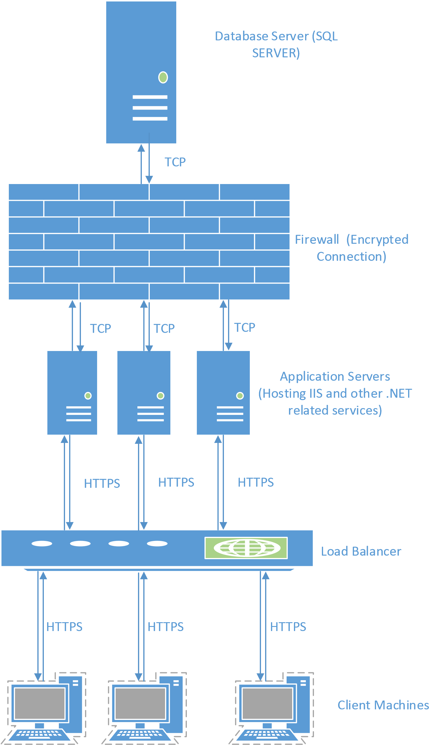

Figure : Deployment Diagram

*Note: this is just an example. Replace it with appropriate diagram.*